
MINI PROJECT REPORT

STARTUP INCUBATOR AI

SUBMITTED BY ,
NAME : KATHIRVEL. T
REGISTER NUMBER : 922524243076
DEPARTMENT : AI&DS - B
ACADEMIC YEAR : 2026 - 2027
YEAR / SEMESTER : III / V Sem

INTRODUCTION
Startup development is an important part of modern business and technological innovation. Many aspiring entrepreneurs have creative business ideas but face difficulties in understanding whether their ideas are technically feasible, financially sustainable, innovative, and suitable for the current market. Traditional startup evaluation methods require extensive market research, expert consultation, financial planning, and competitor analysis. These processes may require considerable time, effort, and financial resources.
Startup Incubator AI is an intelligent web-based platform developed to support entrepreneurs in evaluating and improving their startup ideas. The system uses Artificial Intelligence to analyze the information provided by users and generate meaningful startup insights. Users can submit their startup idea by entering the idea title, detailed explanation, available investment amount, and target platform or industry.
The system processes the submitted information and generates important evaluation results such as Success Rate, Risk Rate, Innovation Score, Required Investment Amount, Budget Analysis, Market Potential, SWOT Analysis, Strategic Recommendations, Similar Startup Information, and a Step-by-Step Execution Roadmap. These results help users understand the strengths, weaknesses, opportunities, risks, and development requirements of their startup concepts.
The application provides secure user registration and login functionality. User information and startup idea history are stored in an SQLite database. JWT-based authentication is used to protect user sessions and restrict unauthorized access. The system also provides profile management, startup idea history, an AI chatbot, an administrator dashboard, user activity monitoring, and PDF report generation.
The frontend of the application is developed using React.js and Vite, providing a modern, responsive, and interactive user interface. The backend is developed using Node.js and Express.js, which manages application logic, authentication, database operations, AI communication, and API services. The Google Gemini AI API is integrated to generate intelligent startup analysis and recommendations.
The main objective of Startup Incubator AI is to simplify the initial startup evaluation process and provide entrepreneurs with quick, intelligent, and data-driven insights. The platform acts as a digital startup assistant that supports users in making informed decisions before investing significant time and money in their business ideas.

KEY FEATURES
1. AI-Based Startup Idea Analysis
The system analyzes the startup idea submitted by the user using Artificial Intelligence and generates meaningful business insights.
2. Startup Success Rate
The application estimates the potential success rate of the startup idea based on its concept, market relevance, innovation, and business feasibility.
3. Risk Rate Analysis
The system identifies possible risks associated with the startup idea and displays a risk percentage to help users understand potential challenges.
4. Innovation Score
An innovation score is generated to indicate the uniqueness, creativity, and technological value of the startup concept.
5. Investment and Budget Analysis
The system compares the user's available investment amount with the estimated required investment and identifies whether the available budget is sufficient.
6. Market Potential Analysis
The platform provides market-related insights such as Total Addressable Market (TAM), Serviceable Available Market (SAM), and Serviceable Obtainable Market (SOM).
7. Automatic SWOT Analysis
The application generates a SWOT analysis containing the strengths, weaknesses, opportunities, and threats related to the startup idea.
8. Strategic Recommendations
AI-generated recommendations help users improve their business model, validate their idea, conduct market research, and develop a Minimum Viable Product (MVP).
9. Step-by-Step Execution Roadmap
The system provides a structured implementation plan containing different phases such as idea validation, planning, MVP development, testing, and product launch.
10. Similar Startup and Competitor Analysis
The application provides information about similar startup concepts and relevant competitors to support market understanding.
11. Secure User Authentication
Users can register and log in securely. Passwords are encrypted using bcrypt, and JWT tokens are used for secure session management.
12. User Profile Management
Users can update their username, email address, and profile image through the profile management feature.
13. Startup Idea History
Previously analyzed startup ideas are stored in the database and can be viewed or managed by the user.
14. PDF Report Generation
Users can generate and download a detailed PDF report containing the startup analysis and AI-generated results.
15. AI Chat Assistant
The integrated AI chatbot provides interactive assistance and answers user queries related to startup development and the platform.
16. Administrator Dashboard
The administrator can monitor platform activity, user engagement, login information, startup ideas, and overall system statistics.
17. Responsive Modern User Interface
The application provides a responsive, attractive, dark-themed glassmorphism interface that works effectively on desktop and mobile devices.

MODULES

The Startup Incubator AI system is divided into the following major modules:

Module 1: User Authentication Module

This module manages user registration and login. New users can create an account by providing a username, email address, and password. Existing users can log in using their credentials. Passwords are securely encrypted using bcrypt, and JWT tokens are generated to maintain authenticated user sessions.

Functions:

User registration

User login

Password encryption

JWT token generation

Secure session management

Guest and administrator access

Module 2: User Profile Management Module

This module allows users to view and update their personal profile information.

Functions:

Update username

Update email address

Upload or change profile image

Store profile image using Base64 format

Module 3: Startup Idea Submission Module

This module collects startup-related information from the user. The submitted information is validated before being sent to the backend.

Input Details:

Startup idea title

Detailed startup explanation

Available investment amount

Target platform or industry

Module 4: AI Startup Analysis Module

This is the core module of the application. It communicates with the Google Gemini AI model and processes the startup information to generate intelligent business insights.

Generated Results:

Success rate

Risk rate

Innovation score

Business feasibility

Market analysis

SWOT analysis

Strategic recommendations

Similar startup information

Module 5: Financial and Budget Analysis Module

This module calculates the estimated investment required for the startup and compares it with the user's available investment amount.

Functions:

Calculate estimated required investment

Calculate remaining investment amount

Identify budget shortage

Display budget sufficiency status

Module 6: Startup Roadmap Module

This module generates a structured execution plan for developing the startup idea.

Roadmap Phases:

Idea validation

Market research

Business planning

MVP development

Beta testing

Product launch

Business growth

Module 7: Startup History Module

This module stores and displays previously generated startup analysis reports.

Functions:

View previous startup ideas

View previous analysis results

Access stored reports

Delete unwanted startup records

Module 8: PDF Report Generation Module

This module converts the startup analysis results into a structured PDF report.

Functions:

Generate startup report

Include startup scores

Include financial analysis

Include recommendations

Download the report in PDF format

Module 9: AI Chat Assistant Module

The AI chatbot helps users interact with the platform and receive startup-related guidance.

Functions:

Answer user questions

Provide startup guidance

Support idea development

Improve user interaction

Module 10: Administrator Dashboard Module

This module provides administrative control and platform monitoring.

Functions:

View total users

Monitor login activity

View total startup ideas

Monitor platform visits

Analyze user activity

View system statistics

Manage automated reports

Module 11: Notification and Automated Report Module

The system uses Nodemailer and scheduled background tasks to generate and send system reports.

Functions:

Send email reports

Generate weekly activity reports

Perform automated background operations

SYSTEM ARCHITECTURE
The Startup Incubator AI system follows a three-tier client-server architecture consisting of the Presentation Layer, Application Layer, and Data Layer.
1. Presentation Layer
The Presentation Layer is developed using React.js and Vite. It provides an interactive and responsive user interface through which users can register, log in, submit startup ideas, view AI-generated results, manage profiles, access startup history, communicate with the AI chatbot, and download reports.
2. Application Layer
The Application Layer is developed using Node.js and Express.js. It manages REST API requests, user authentication, business logic, input validation, AI integration, financial calculations, report generation, and communication between the frontend and the database.
3. Artificial Intelligence Layer
The Google Gemini AI API is integrated into the backend. The AI model processes the startup title, explanation, investment amount, and target industry. It generates feasibility insights, startup scores, SWOT analysis, recommendations, market information, and an execution roadmap.
4. Data Layer
SQLite is used as the primary database for storing user information, startup ideas, analysis results, activity information, and application statistics. Structured information such as recommendations and implementation steps is stored in JSON format where required.
5. Security Layer
The application uses bcrypt for password encryption and JWT for secure authentication. Helmet is used to improve HTTP security, Zod is used for input validation, and rate limiting is used to reduce excessive API requests.
Working Process
- The user accesses the React-based web application.
- The user registers or logs into the system.
- The user enters startup idea information.
- The frontend validates and sends the information to the Express.js backend.
- The backend validates the data using Zod.
- The backend sends the startup information to the Gemini AI model.
- The AI model generates startup analysis results.
- The backend processes and stores the results in SQLite.
- The generated results are returned to the frontend.
- The user views the analysis dashboard and downloads the PDF report.
Architecture Diagram:
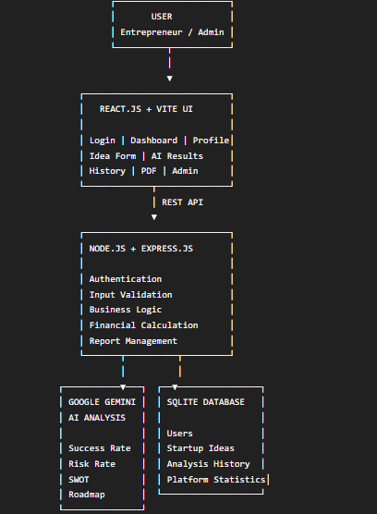

IMPLEMENTATION (CODING)

The Startup Incubator AI application is implemented using a full-stack web development approach. The frontend is developed using React.js and Vite, while the backend is developed using Node.js and Express.js. SQLite is used to store application data, and Google Gemini AI is integrated to generate intelligent startup analysis.

Frontend Implementation

The frontend is responsible for displaying the user interface and managing user interactions. React components are used to implement the login page, startup idea form, AI analysis dashboard, profile page, startup history, chatbot, and administrator dashboard.

React Hooks such as useState and useEffect are used to manage application data and update the user interface dynamically.

Backend Implementation

The backend is implemented using Express.js. It provides REST APIs for registration, login, profile management, startup idea submission, startup history, administrative functions, and AI analysis.

The backend validates user input, authenticates users using JWT, communicates with the Gemini AI API, performs financial calculations, and stores results in the SQLite database.

Database Implementation

SQLite is used to store user information and startup idea analysis results. The database contains user records, startup idea details, AI-generated scores, recommendations, implementation steps, and activity statistics.

AI Implementation

Google Gemini AI is integrated with the backend. The user's startup information is provided to the AI model through a structured prompt. The generated response is processed and returned as startup evaluation results.

Security Implementation

The application implements multiple security mechanisms:

Password encryption using bcrypt

JWT-based authentication

Input validation using Zod

API rate limiting

HTTP security using Helmet

Protected API routes
Important Code Example 1: User Registration
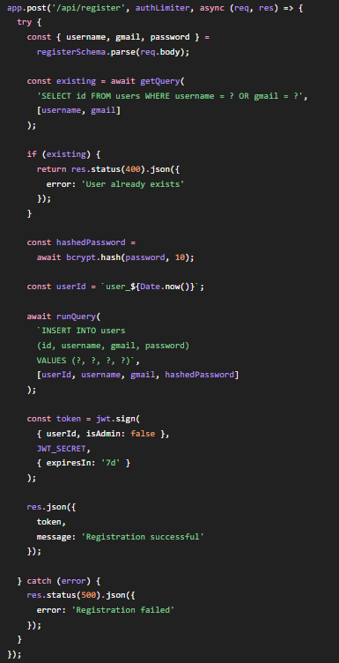
Important Code Example 2: JWT Authentication
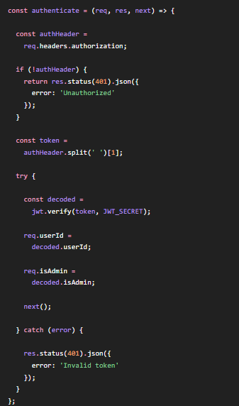
Important Code Example 3: Startup Idea Processing
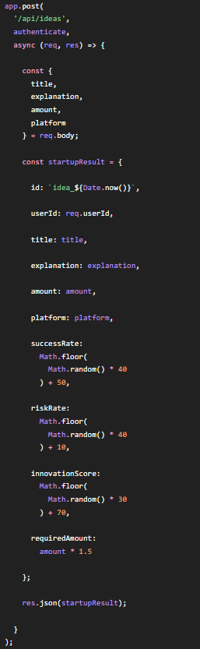
Important Code Example 4: AI Model Integration
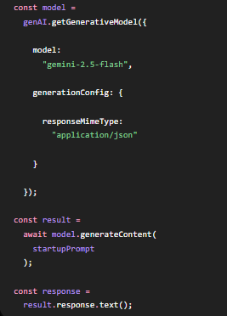
Important Code Example 5: React Startup State
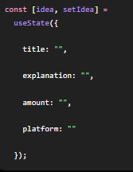
The complete source code is organized into frontend and backend folders. The frontend contains React components and styling files, while the backend contains API routes, database operations, authentication logic, AI integration, and server configuration.

OUTPUT SCREENSHOTS

The following screenshots demonstrate the major functions and outputs of the Startup Incubator AI application.

Screenshot 1: Home Page

The home page introduces the Startup Incubator AI platform and displays the main features of the system. It provides navigation options for registration, login, and startup analysis.

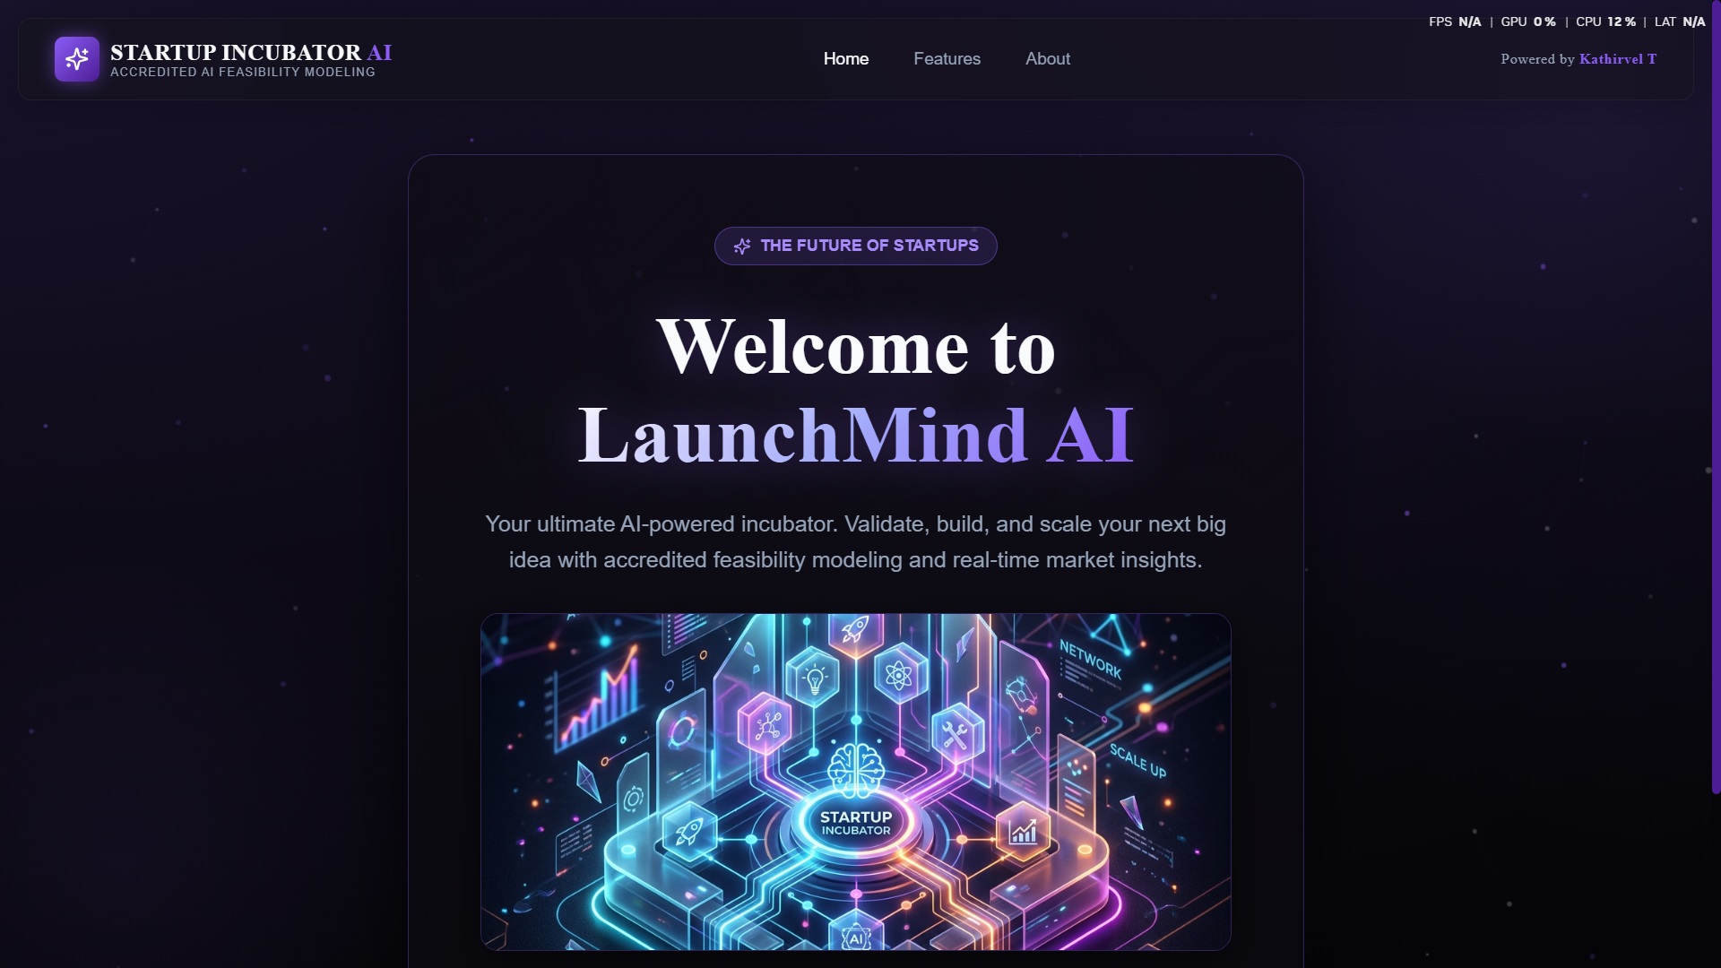

Screenshot 2: User Registration Page

The registration page allows new users to create an account by entering their username, email address, and password.

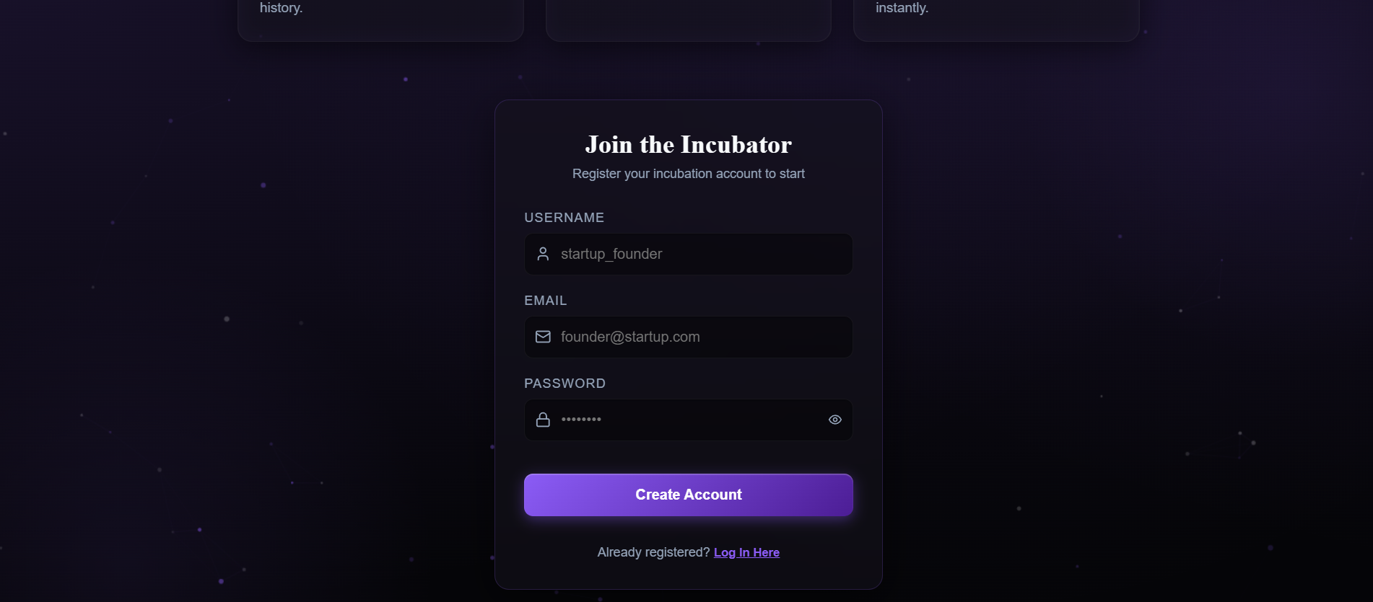Screenshot 3: User Login Page

The login page allows registered users to securely access the Startup Incubator AI platform.

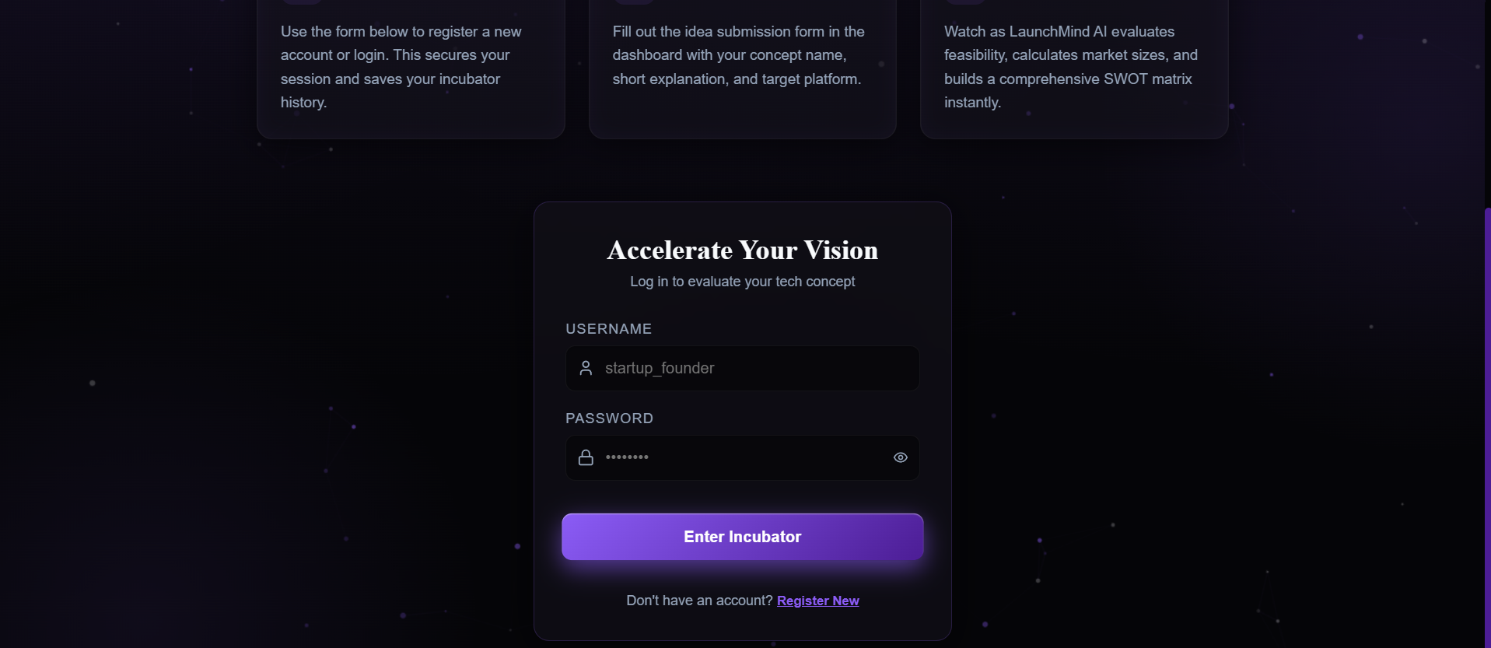Screenshot 4: Startup Idea Submission Form

The startup idea form collects the startup title, detailed explanation, available investment amount, and target industry or platform.

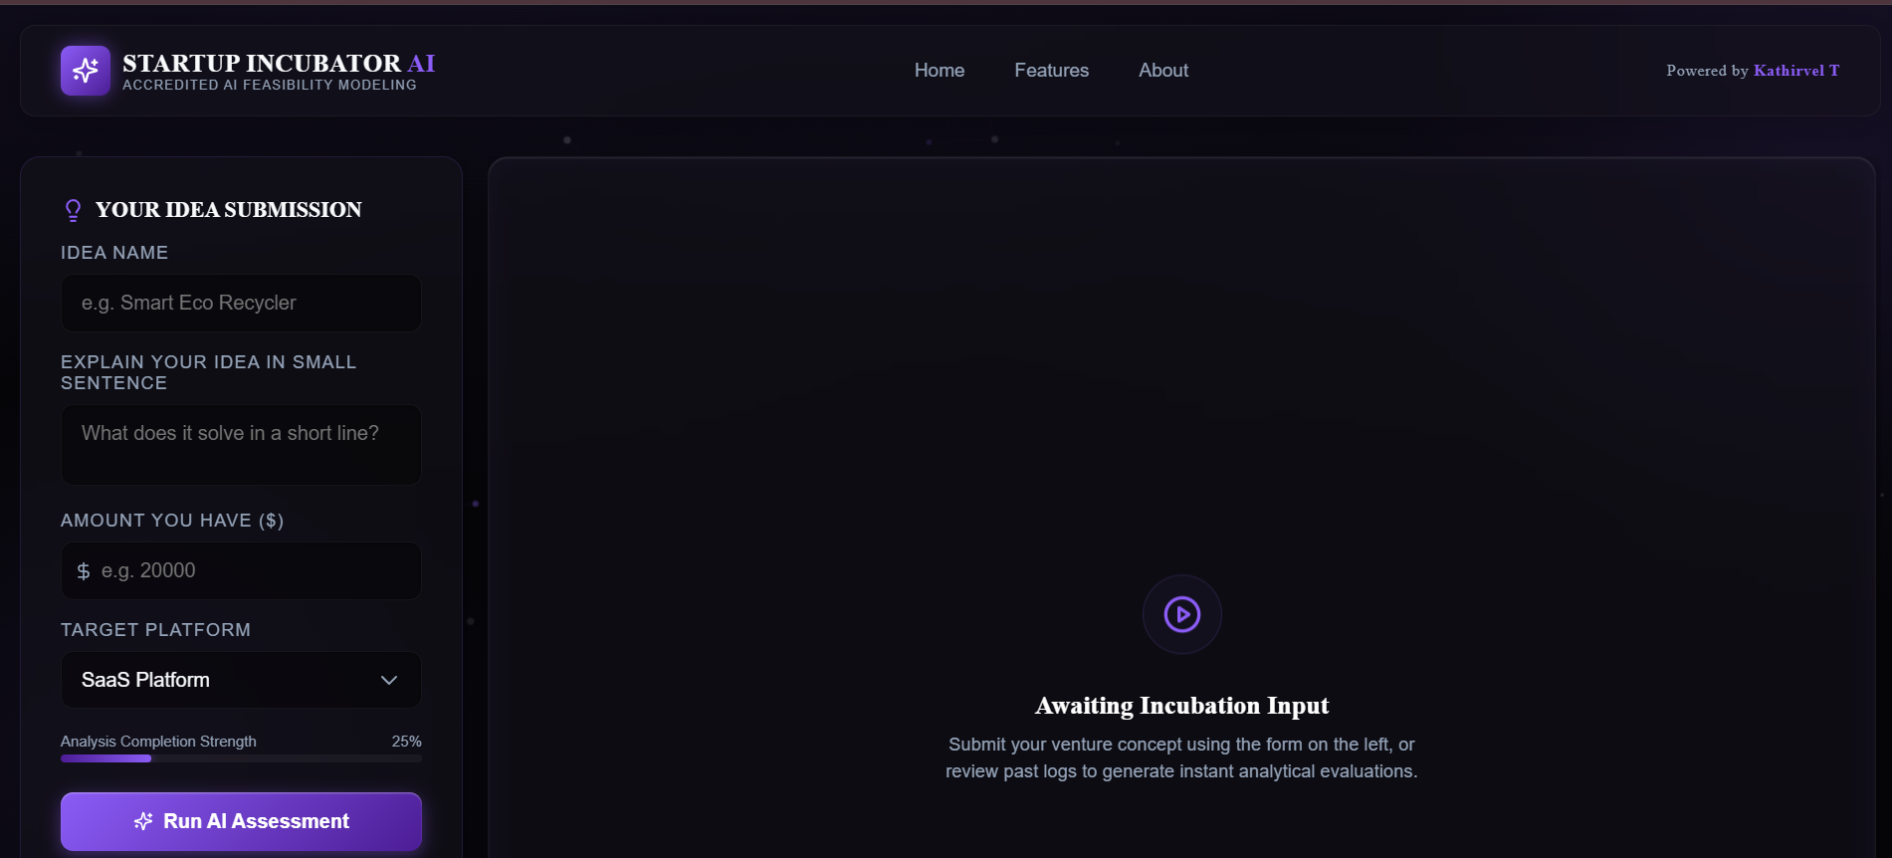

Screenshot 5: AI Startup Analysis Dashboard
The analysis dashboard displays the AI-generated Success Rate, Risk Rate, Innovation Score, and other startup evaluation results.
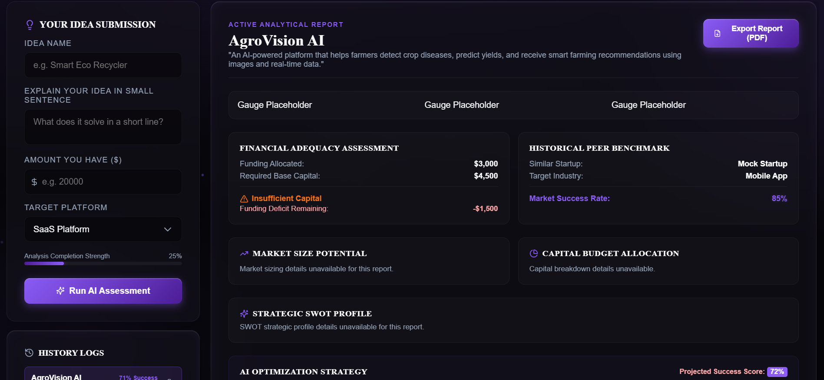
Screenshot 6: Financial and Budget Analysis
This screen displays the available investment amount, estimated required investment, remaining amount, and budget sufficiency status.
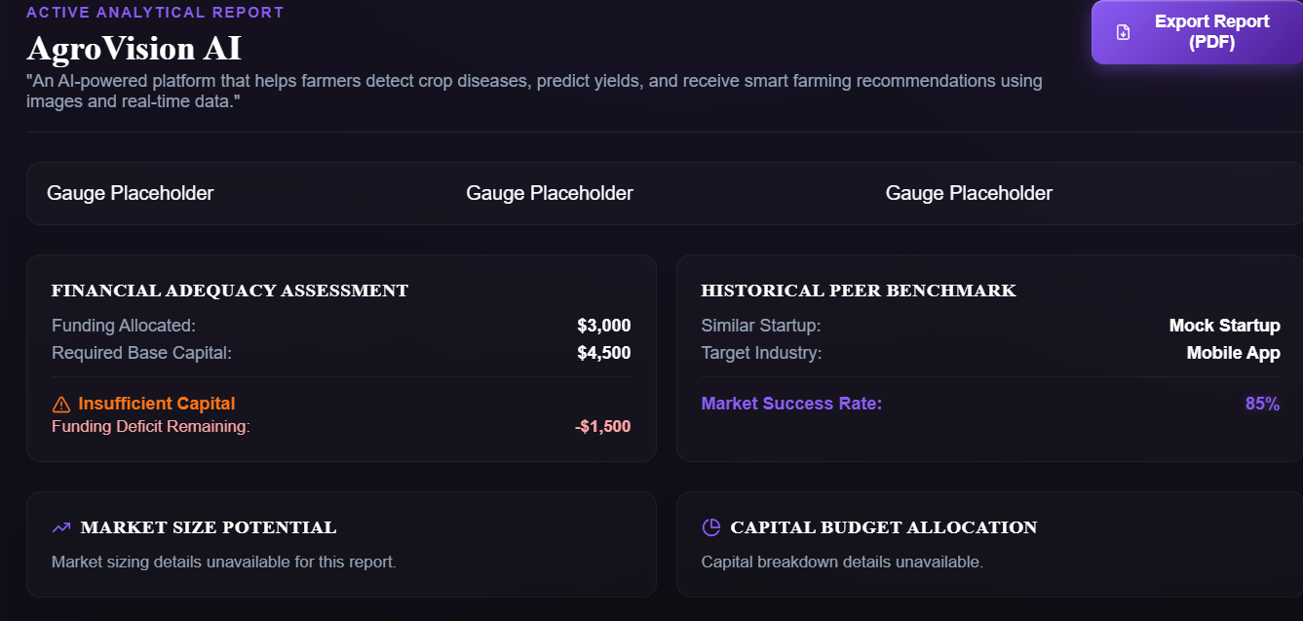

Screenshot 7: SWOT Analysis
The SWOT analysis screen displays the strengths, weaknesses, opportunities, and threats related to the submitted startup idea.
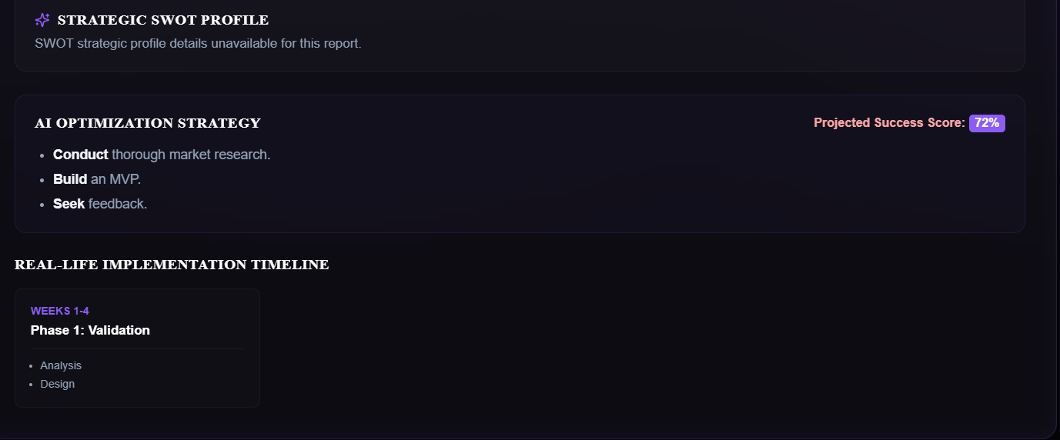
Screenshot 8: User Profile Page
The profile page allows users to update their username, email address, and profile image.
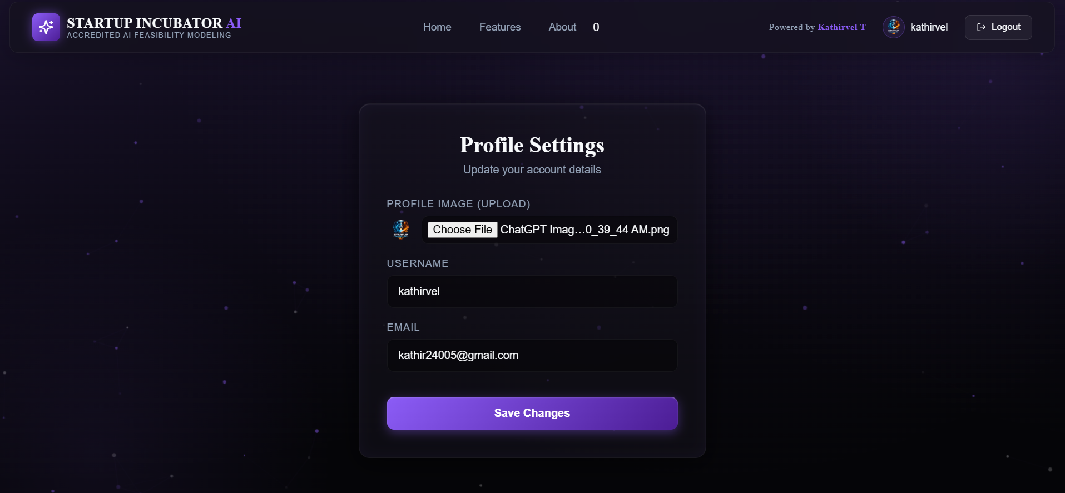
Screenshot 9: Generated PDF Report
The PDF report contains the complete startup analysis and can be downloaded by the user.
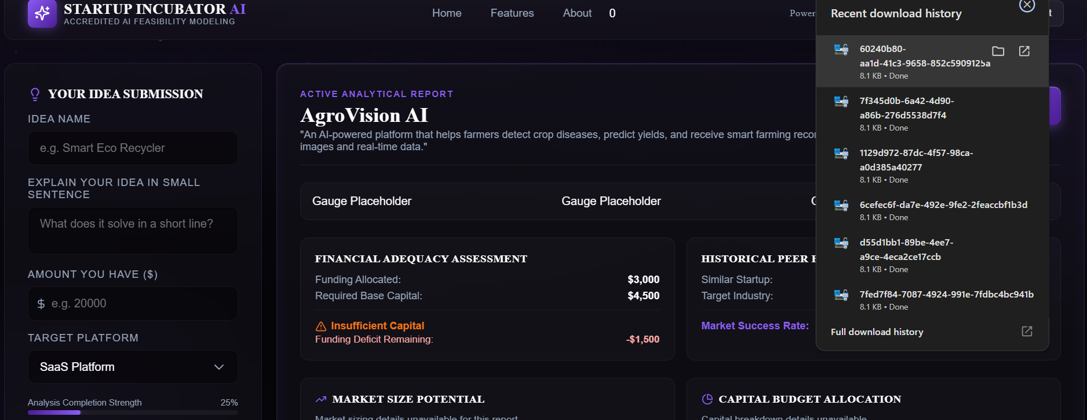

Screenshot 10: Administrator Dashboard
The administrator dashboard displays platform statistics, user information, startup activity, and system analytics.
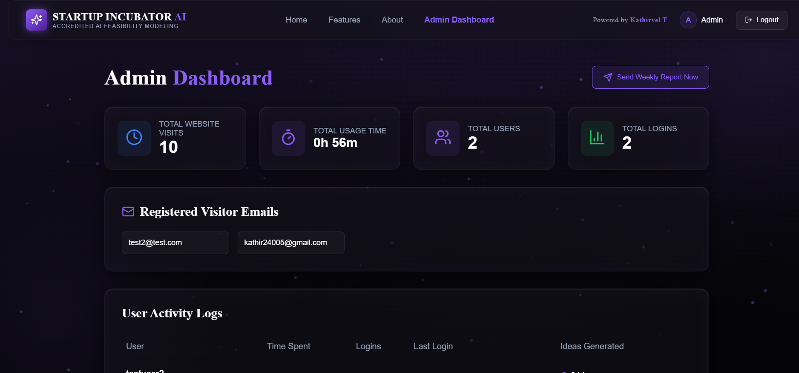

DIAGRAMS
A. Use Case Diagram
Your project already contains a Use Case Diagram. Use the following actors:
Actors:
- Entrepreneur/User
- Administrator
- Automated System
User Functions:
- Register/Login
- Manage Profile
- Submit Startup Idea
- View AI Analysis
- Review Market and Financial Details
- Download PDF Report
- View Startup History
Admin Functions:
- View Platform Analytics
- Monitor User Activity
- Generate Reports

B. ER Diagram
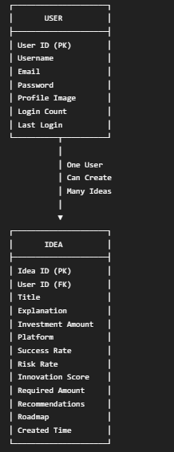
Relationship:
USER 1 ───────────── M IDEA
One user can submit multiple startup ideas, but each startup idea belongs to one user.

C. Data Flow Diagram – Level 0

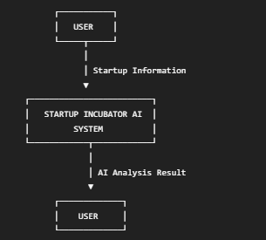

D. Data Flow Diagram – Level 1
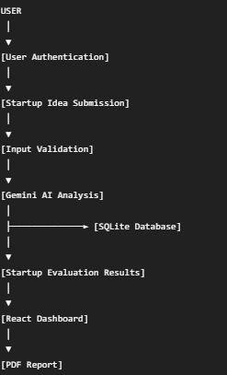
E. Activity Diagram
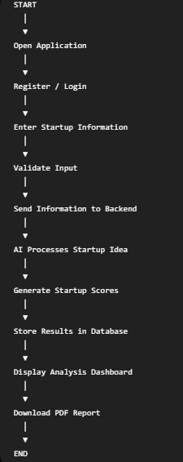

SOFTWARES USED
The following software tools and development environments were used to design, develop, test, and deploy the Startup Incubator AI application
S.No | Software / Tool | Purpose
1 | Visual Studio Code | Source code development and editing
2 | Node.js | JavaScript runtime used for backend execution
3 | npm | Package installation and dependency management
4 | React.js | Frontend user interface development
5 | Vite | Frontend development server and build tool
6 | Express.js | Backend API and server development
7 | SQLite | Local database management
8 | Google Gemini API | AI-based startup idea analysis
9 | Postman | REST API testing and validation
10 | Google Chrome | Application testing and execution
11 | Git | Version control and source code tracking
12 | GitHub | Source code repository management
13 | jsPDF | PDF report generation
14 | Draw.io | System architecture and UML diagram creation
15 | Canva | Presentation and visual design
16 | Render | Application deployment and hosting
17 | Windows Operating System | Development environment

TECHNOLOGY STACK

The Startup Incubator AI application uses the following technologies:

Frontend Technologies

React.js:
React.js is used to develop a dynamic, component-based, and interactive user interface.

Vite:
Vite is used as the frontend development and build tool. It provides fast development, hot module replacement, and optimized production builds.

JavaScript:
JavaScript is used to implement frontend functionality, user interactions, API communication, and application logic.

HTML5:
HTML5 is used to create the structural layout of the web application.

CSS3:
CSS3 is used to design the responsive user interface, animations, glassmorphism effects, dark theme, and visual components.

Lucide React:
Lucide React provides modern icons for the user interface.

Backend Technologies

Node.js:
Node.js provides the JavaScript runtime environment for executing backend services.

Express.js:
Express.js is used to create REST APIs and manage backend routing and application logic.

Database Technology

SQLite:
SQLite is used to store user details, startup ideas, AI-generated results, activity information, and system statistics.

Artificial Intelligence Technology

Google Gemini AI:
Google Gemini AI is integrated to analyze startup concepts and generate feasibility scores, recommendations, SWOT analysis, market insights, and development roadmaps.

Security Technologies

bcrypt:
bcrypt is used to securely encrypt user passwords.

JSON Web Token (JWT):
JWT is used to authenticate users and maintain secure login sessions.

Helmet:
Helmet is used to improve the security of HTTP requests and responses.

Zod:
Zod is used to validate user input before processing it in the backend.

Express Rate Limit:
Rate limiting is used to reduce excessive API requests and improve application security.

Additional Technologies

Nodemailer:
Nodemailer is used to send automated email reports.

node-cron:
node-cron is used to schedule automated background tasks.

jsPDF:
jsPDF is used to generate downloadable startup analysis reports.

Base64:
Base64 encoding is used to store and manage user profile images.

ADVANTAGES AND DISADVANTAGES

Advantages

Quick Startup Evaluation
The system provides startup analysis within a short period and reduces the time required for manual evaluation.

AI-Powered Insights
Artificial Intelligence generates intelligent recommendations and business insights based on the submitted startup information.

Supports Better Decision-Making
The success score, risk score, innovation score, and financial analysis help users make informed business decisions.

Reduces Initial Research Effort
The system provides market insights, SWOT analysis, recommendations, and a development roadmap in one platform.

User-Friendly Interface
The modern and responsive interface makes the application easy to use.

Secure Authentication
Password encryption and JWT authentication help protect user accounts and application data.

Startup History Management
Users can access their previously analyzed startup ideas and results.

Automated Report Generation
Users can download startup analysis reports in PDF format.

Centralized Startup Support
Multiple startup evaluation features are integrated into a single web application.

Administrator Monitoring
The administrator dashboard supports platform monitoring and user activity analysis.

Disadvantages

AI Results May Not Always Be Accurate
The generated startup scores and recommendations depend on the information provided by the user and the AI model.

Internet Dependency
Internet access is required when using cloud-based AI services.

Limited Real-Time Market Data
The current system does not directly integrate live stock, business, or market databases.

AI API Dependency
The quality and availability of AI analysis depend on the external Gemini AI service.

Limited Financial Prediction
The investment calculations provide estimated values and should not be considered professional financial advice.

SQLite Scalability Limitations
SQLite is suitable for small and medium applications but may require migration to MySQL or PostgreSQL for large-scale deployment.

Limited Competitor Data
Competitor information may not include all real-world businesses and market competitors.

Requires User Input Quality
Incorrect or incomplete startup information may produce less useful analysis results.

CONCLUSION

Startup Incubator AI is an intelligent web-based startup evaluation platform developed to help entrepreneurs analyze and improve their business ideas. The system combines modern web technologies, database management, secure authentication, and Artificial Intelligence to provide a complete startup evaluation experience.

The application allows users to submit startup information and receive AI-generated results such as Success Rate, Risk Rate, Innovation Score, Market Insights, SWOT Analysis, Financial Requirements, Strategic Recommendations, Similar Startup Information, and a Step-by-Step Execution Roadmap. These features help users understand the potential strengths and challenges of their startup concepts before making major investments.

The system provides secure registration and login functionality using bcrypt password encryption and JWT authentication. SQLite is used to store user information and startup analysis history. The React.js frontend provides a responsive and interactive user interface, while the Node.js and Express.js backend manages application logic, AI communication, database operations, and REST APIs.

The PDF report generation feature allows users to save and share their startup analysis results. The administrator dashboard supports platform monitoring and user activity analysis. Additional features such as the AI chatbot, profile management, automated reports, and startup history improve the overall usability of the platform.

The project successfully demonstrates the practical integration of Artificial Intelligence with full-stack web development. Startup Incubator AI reduces the effort required for initial startup evaluation and provides users with useful data-driven insights. The system can be further improved by integrating real-time market data, advanced machine learning models, live competitor information, investor matching, and cloud-based scalable databases.

Thus, Startup Incubator AI serves as a digital startup assistant that supports aspiring entrepreneurs in evaluating ideas, identifying risks, planning development activities, and making more informed business decisions.

REFERENCES

React.js Official Documentation, Meta Open Source.
Available at: React Documentation.

Node.js Official Documentation.
Available at: Node.js Documentation.

Express.js Official Documentation.
Available at: Express.js Documentation.

Google Gemini API Documentation, Google AI for Developers.
Available at: Google AI Documentation.

SQLite Official Documentation.
Available at: SQLite Documentation.

JSON Web Token Documentation.
Available at: JWT Documentation.

bcrypt Documentation.
Available at: bcrypt Documentation.

Vite Official Documentation.
Available at: Vite Documentation.

jsPDF Official Documentation.
Available at: jsPDF Documentation.

PROJECT/GITHUB LINK:
Github Link:

https://github.com/Kathirvel005/Startup-incubator-ai-v3
Deploy Link:
https://ideava.onrender.com

THANKYOU !!

